DATA CLEANING AND PREPROCESSING OF A PUBLIC DATASET
Author: Logistics Data Analyst Intern
Task: Week 1 Task- Data Acquisition, Cleaning and Preprocessing
Date: September 4, 2026

TABLE OF CONTENTS
- Introduction
- Objective of the Task
- Dataset Selection
- Data Acquisition
- Initial Data Exploration
- Data Quality Assessment
- Handling Missing Values
- Detecting and Handling Duplicate Records
- Detecting Inconsistent and Erroneous Entries
- Outlier Detection and Treatment
- Data Preprocessing
- Final Dataset After Preprocessing
- Challenges Faced and Solutions
- Impact of Preprocessing on Further Analysis
- Conclusion
- Appendix – Python Code

1. INTRODUCTION
Data is one of the most important resources in modern data analysis and decision-making. However, raw datasets often contain missing values, duplicate records, inconsistent entries, incorrect data types, and unusual observations. If these problems are not addressed properly, they can negatively affect the accuracy and reliability of subsequent statistical analysis and machine learning models.
Data cleaning and preprocessing are therefore essential steps in the data analysis process. They involve examining the quality of raw data, identifying potential problems, correcting or removing inappropriate records, and transforming the data into a suitable format for analysis.
This report presents the process of acquiring, exploring, cleaning, and preprocessing the Titanic dataset using Python. The analysis demonstrates different techniques for identifying missing values, duplicate records, inconsistent entries, and outliers. Appropriate preprocessing techniques are then applied to prepare the dataset for further statistical analysis or machine learning applications.

2. OBJECTIVE OF THE TASK
The main objective of this task is to demonstrate the practical process of preparing a publicly available dataset for further analysis.
The specific objectives are:
- To acquire a publicly available dataset from a reliable source.
- To understand the structure and characteristics of the dataset.
- To identify missing values and determine suitable methods for handling them.
- To identify duplicate and inconsistent records.
- To detect potential outliers in numerical variables.
- To preprocess categorical and numerical variables appropriately.
- To document the cleaning and preprocessing process using Python.
- To evaluate how preprocessing decisions may influence subsequent analysis.
- To develop a clean and analysis-ready dataset.

3. DATASET SELECTION
3.1 Dataset Name
The dataset selected for this task is the Titanic Dataset(train.csv).
The Titanic dataset contains information about passengers who travelled on the RMS Titanic. It is commonly used for demonstrating data analysis and machine learning techniques because it contains numerical variables, categorical variables, missing values, and other data-quality issues.
3.2 Reason for Selecting the Dataset
The Titanic dataset was selected because it provides a suitable example for demonstrating the complete data cleaning and preprocessing workflow.
The dataset contains:
- Numerical variables such as age, fare, and passenger class.
- Categorical variables such as sex, embarked port, and passenger class.
- Missing observations.
- Potential duplicate records.
- Variables that require transformation before machine learning.
- Numerical variables that can be examined for possible outliers.
Therefore, the dataset provides sufficient opportunities to demonstrate different data preprocessing techniques required for this task.

3.3 Important Variables
Some of the important variables in the dataset are:
Variable | Description
PassengerId | Unique identification number of a passenger
Survived | Indicates whether the passenger survived
Pclass | Passenger class
Name | Passenger's name
Sex | Passenger's sex
Age | Passenger's age
SibSp | Number of siblings/spouses aboard
Parch | Number of parents/children aboard
Ticket | Ticket number
Fare | Passenger fare
Cabin | Cabin information
Embarked | Port of embarkation

4. DATA ACQUISITION
The Titanic dataset was obtained from a publicly available dataset source. The dataset was downloaded in CSV format and imported into Python using the Pandas library.
Python provides several libraries that are useful for data analysis. In this project, Pandas was primarily used for data manipulation and NumPy was used for numerical operations.
4.1 Importing Required Libraries
The following libraries were imported:
import pandas as pd
import numpy as np
import matplotlib.pyplot as plt
import seaborn as sns

Pandas was used for loading and manipulating the dataset, NumPy for numerical operations, Matplotlib and Seaborn for visualization.
4.2 Loading the Dataset
df = pd.read_csv("train.csv")

The dataset was loaded into a Pandas DataFrame named df.
To verify that the dataset was loaded correctly, the first few records were displayed:
df.head()
[INSERT SCREENSHOT OF df.head() HERE]
The output provides an initial view of the dataset and helps confirm that the columns and observations have been loaded correctly.

5. INITIAL DATA EXPLORATION
Initial data exploration was performed before making any changes to the dataset. This step is important because it provides an understanding of the structure, size, variables, and general quality of the raw data.
5.1 Checking Dataset Dimensions
df.shape
The shape attribute returns the number of rows and columns in the dataset.The result indicates the total number of observations and variables available in the raw dataset.
5.2 Viewing the Dataset
df.head()
The first five records were examined to understand the format and type of information stored in each column.
df.tail()
The last five records were also examined to ensure that the dataset had been loaded completely.
5.3 Checking Column Names
df.columns
This was used to identify all variables available in the dataset.
5.4 Checking Data Types
df.dtypes
The data types of the variables were examined to identify numerical and categorical variables and to detect any columns that might require conversion.
5.5 Dataset Information
df.info()
The info() function provides information about the number of non-null observations and the data type of each variable.This step is particularly useful for identifying columns containing missing values.
5.6 Descriptive Statistics
df.describe()
The describe() function was used to obtain summary statistics for numerical variables, including count, mean, standard deviation, minimum, maximum, and quartile values.These statistics provide an initial understanding of the distribution and range of numerical variables.

6. DATA QUALITY ASSESSMENT
After exploring the basic structure of the dataset, a data-quality assessment was performed.
The major issues investigated were:
- Missing values
- Duplicate records
- Incorrect or inconsistent entries
- Incorrect data types
- Potential outliers
6.1 Checking Missing Values
df.isnull().sum()
This code calculates the number of missing values in each column.The results were examined to determine which variables required further treatment.The presence of missing values does not automatically mean that the corresponding rows should be deleted. The appropriate treatment depends on the importance of the variable, the amount of missing data, and the potential impact of removing observations.

7. HANDLING MISSING VALUES
Missing values are one of the most common problems encountered in real-world datasets. Simply deleting all rows containing missing values can result in unnecessary information loss. Therefore, different strategies were considered depending on the variable.
7.1 Missing Values in Age
The Age variable contains missing observations. Since age is a numerical variable, missing values can be replaced using an appropriate measure of central tendency.
The median was selected because it is less sensitive to extreme values than the mean.
df['Age'] = df['Age'].fillna(df['Age'].median())
After filling the missing values, the result was verified:
df['Age'].isnull().sum()
The missing values in the Age column were therefore replaced with the median age.
7.2 Missing Values in Embarked
The Embarked variable is categorical. Since only a small number of observations are missing, the mode can be used as a simple method of imputation.
df['Embarked'] = df['Embarked'].fillna(df['Embarked'].mode()[0])
The result was then checked:
df['Embarked'].isnull().sum()
7.3 Handling Cabin
The Cabin variable contains a relatively large number of missing observations. Replacing such a large proportion of missing cabin information with a single value could introduce misleading information.
Instead of attempting to guess the exact cabin number, the variable can be transformed into a simpler indicator showing whether cabin information was available.
df['CabinAvailable'] = df['Cabin'].notnull().astype(int)
This creates a new variable:
- 1 = Cabin information was available
- 0 = Cabin information was missing
After creating this indicator, the original Cabin column can be removed if it is not required for the planned analysis.
df.drop('Cabin', axis=1, inplace=True)
This approach preserves some useful information about cabin availability without artificially assigning cabin numbers to missing observations.

8. DETECTING AND HANDLING DUPLICATE RECORDS
Duplicate records can cause certain observations to be counted more than once and may therefore affect statistical analysis.
The number of duplicate rows was checked using:
df.duplicated().sum()
If duplicate records are identified, they can be removed using:
df = df.drop_duplicates()
The dataset was then checked again:
df.duplicated().sum()
If no duplicate rows were found, no deletion was necessary.
Duplicate removal should only be performed when records are genuinely duplicated. Removing valid repeated observations could result in information loss.

9. DETECTING INCONSISTENT AND ERRONEOUS ENTRIES
Data inconsistencies can occur when values are entered using different formats or when unexpected values are present.
9.1 Checking Categorical Values
The unique values of categorical variables were examined.
df['Sex'].unique()
df['Embarked'].unique()
df['Pclass'].unique()

This helps identify unexpected categories, spelling differences, or invalid values.
9.2 Checking Numerical Ranges
The minimum and maximum values of important numerical variables were examined.
df[['Age', 'Fare', 'SibSp', 'Parch']].describe()
Values outside a reasonable range were considered potential data-quality issues and were investigated before deciding whether any correction was necessary.
It is important not to automatically remove unusual values because an unusual observation is not necessarily an erroneous observation.

10. OUTLIER DETECTION AND TREATMENT
Outliers are observations that are unusually distant from most other observations in a dataset. They can influence summary statistics and some machine learning algorithms.
The numerical variables Age and Fare were examined for potential outliers.
10.1 Box Plot for Age
plt.figure(figsize=(8,5))
sns.boxplot(x=df['Age'])
plt.title('Box Plot of Age')
plt.show()

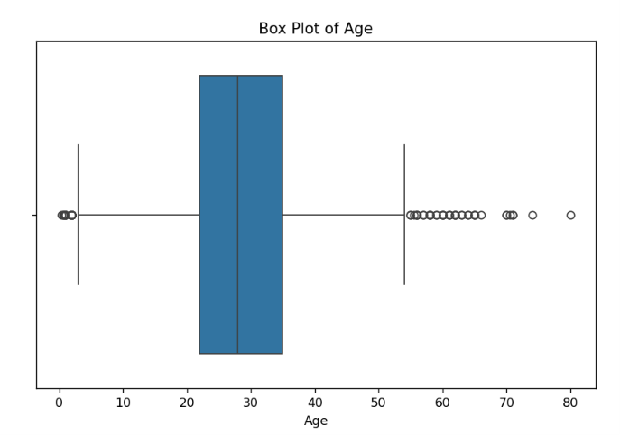
The box plot was used to visually identify observations that may be unusually high or low.
10.2 Box Plot for Fare
plt.figure(figsize=(8,5))
sns.boxplot(x=df['Fare'])
plt.title('Box Plot of Fare')
plt.show()

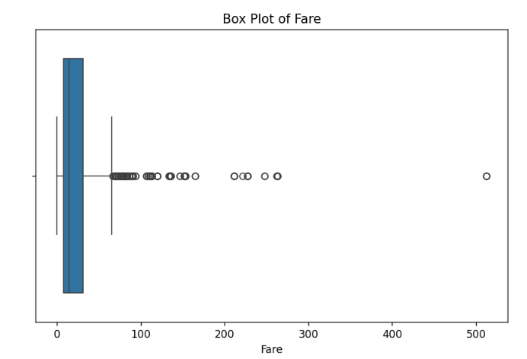
The Fare variable may contain high-value observations. However, a high fare does not necessarily represent an error. It may correspond to a passenger travelling under a different ticket class or purchasing a ticket for multiple individuals.
Therefore, outliers were not automatically deleted merely because they were statistically unusual.
10.3 IQR Method
The Interquartile Range (IQR) method can be used to identify potential outliers.
Q1 = df['Fare'].quantile(0.25)
Q3 = df['Fare'].quantile(0.75)

IQR = Q3 - Q1

lower_bound = Q1 - 1.5 * IQR
upper_bound = Q3 + 1.5 * IQR

outliers = df[(df['Fare'] < lower_bound) |
(df['Fare'] > upper_bound)]

print("Number of potential outliers:", len(outliers))

The IQR method identifies observations outside the lower and upper boundaries.
However, statistical identification alone is not enough to justify deleting an observation. In this dataset, unusually high fares may represent genuine passenger records. Therefore, such observations should generally be retained unless there is evidence that they are erroneous.
This decision reduces the risk of removing valid information from the dataset.

11. DATA PREPROCESSING
After cleaning the dataset, preprocessing techniques were applied to prepare the variables for further analysis.
11.1 Removing Unnecessary Columns
Some variables may not be directly useful for a basic predictive analysis. For example, Passenger Id is an identifier rather than a meaningful predictive feature.
Depending on the intended analysis, unnecessary columns can be removed:
df.drop(['PassengerId'], axis=1, inplace=True)
Other identifier-like variables such as Name and Ticket can also be removed if they are not required.
df.drop(['Name', 'Ticket'], axis=1, inplace=True)
The decision to remove variables should depend on the objective of the subsequent analysis.

11.2 Encoding Categorical Variables
Machine learning algorithms generally require numerical input. Therefore, categorical variables need to be converted into numerical form.
The Sex variable can be encoded as:
df['Sex'] = df['Sex'].map({'male': 0, 'female': 1})
For the Embarked variable, one-hot encoding can be used:
df = pd.get_dummies(df, columns=['Embarked'], drop_first=True)
This converts categorical categories into numerical indicator variables.
11.3 Checking the Preprocessed Dataset
After preprocessing, the structure of the dataset was checked:
df.head()
df.info()
df.isnull().sum()

These checks ensure that the preprocessing steps were successfully applied.

12. FINAL DATASET AFTER PREPROCESSING
After completing the cleaning and preprocessing procedures, the dataset was examined again to confirm that it was suitable for further analysis.
The following checks were performed:
print("Shape:", df.shape)
print("\nMissing values:")
print(df.isnull().sum())
print("\nDuplicate rows:", df.duplicated().sum())

The final dataset was checked for:
- Remaining missing values
- Duplicate observations
- Appropriate data types
- Properly encoded categorical variables
- Unnecessary columns
- Potentially problematic numerical observations
The resulting dataset is substantially more suitable for statistical analysis and machine learning than the original raw dataset.

13. CHALLENGES FACED AND SOLUTIONS
Several challenges were encountered during the data cleaning and preprocessing process.
Challenge 1: Missing Values
The dataset contained missing observations in some variables. Removing every row containing a missing value could have resulted in unnecessary loss of information.
Solution:
Different strategies were used depending on the variable. Median imputation was used for the numerical Age variable, while mode imputation was appropriate for the categorical Embarked variable. Cabin information was transformed into a binary availability indicator instead of attempting to guess missing cabin numbers.
Challenge 2: Outliers
Some numerical variables, particularly Fare, contained observations that could be classified as potential outliers.
Solution:
Box plots and the IQR method were used to identify unusual observations. The observations were not automatically removed because an extreme value does not necessarily represent an error. Domain context was considered before making a preprocessing decision.

Challenge 3: Categorical Variables
Categorical variables cannot always be directly used by machine learning algorithms.
Solution:
Categorical variables were converted into numerical representations using label mapping and one-hot encoding.
Challenge 4: Choosing Appropriate Preprocessing Methods
Different variables require different preprocessing strategies. Applying the same technique to every variable could introduce bias or unnecessary information loss.
Solution:
Each variable was examined individually, and preprocessing decisions were based on the variable's data type, missingness, meaning, and potential effect on later analysis.

14. IMPACT OF PREPROCESSING ON FURTHER ANALYSIS
Data preprocessing can have a significant impact on subsequent statistical analysis and machine learning models.
Handling missing values helps ensure that analytical methods receive complete observations and prevents errors caused by unavailable values. However, imputation can introduce assumptions because the replacement value may not perfectly represent the original missing observation.
Removing duplicate records prevents the same observation from being counted multiple times.
Encoding categorical variables makes the dataset compatible with algorithms that require numerical input.
Outlier treatment can also affect statistical measures such as the mean and standard deviation. However, removing genuine extreme observations may eliminate useful information. For this reason, outliers should only be removed when there is sufficient evidence that they are erroneous or inappropriate for the intended analysis.
Overall, preprocessing improves data quality and consistency, but every preprocessing decision should be carefully documented because it can influence the conclusions obtained from later analysis.

15. CONCLUSION
This project demonstrated the complete workflow of acquiring, exploring, cleaning, and preprocessing a publicly available dataset using Python.
The Titanic dataset was examined to understand its structure and identify data-quality problems. Missing values were investigated and treated using appropriate methods based on the characteristics of individual variables. Duplicate records and potential inconsistencies were checked, while numerical variables were examined for potential outliers using visualization and the IQR method.
Categorical variables were converted into numerical representations, and unnecessary variables were removed where appropriate. The final dataset was then checked to ensure that it was suitable for further analysis.
The project also demonstrated that data preprocessing is not simply a technical procedure. Each decision can affect subsequent statistical analysis and machine learning results. Therefore, preprocessing should be performed carefully, with consideration given to the meaning of the data and the potential consequences of each decision.
The cleaned and preprocessed Titanic dataset can now be used as a foundation for further exploratory data analysis, visualization, statistical analysis, or machine learning.

